1. Layered Based-Architecture.
2. Every instruction in a Dockerfile represents a layer.
3. An image is built up from multiple layers based on these different instructions.
4. These layers are cached.
5. When you run an image, it adds one extra layer around the layers on top of the image and this extra layer is where your app is running.  
   App: This extra layer is where the CMD command specified in Dockerfile is executed.  
   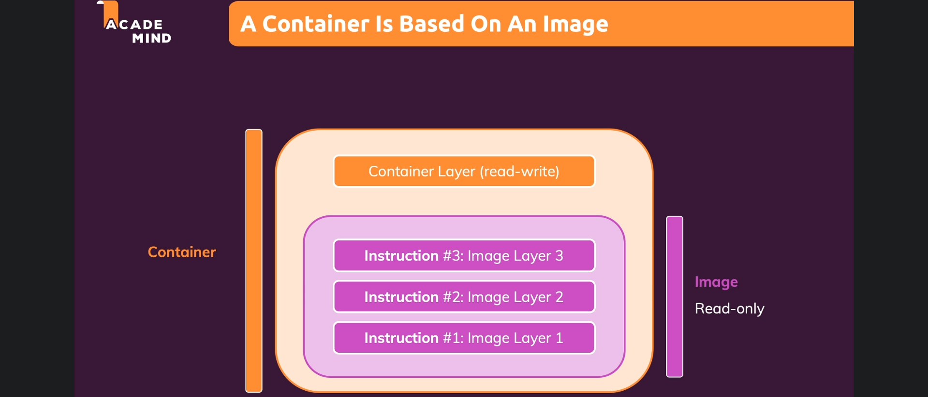
6. All the instructions except the last instruction (CMD [“node”, “server.js”]) is part of the image as separate layers and if nothing changes, these layers can be used from the cache as all layers are stored in cache.
7. 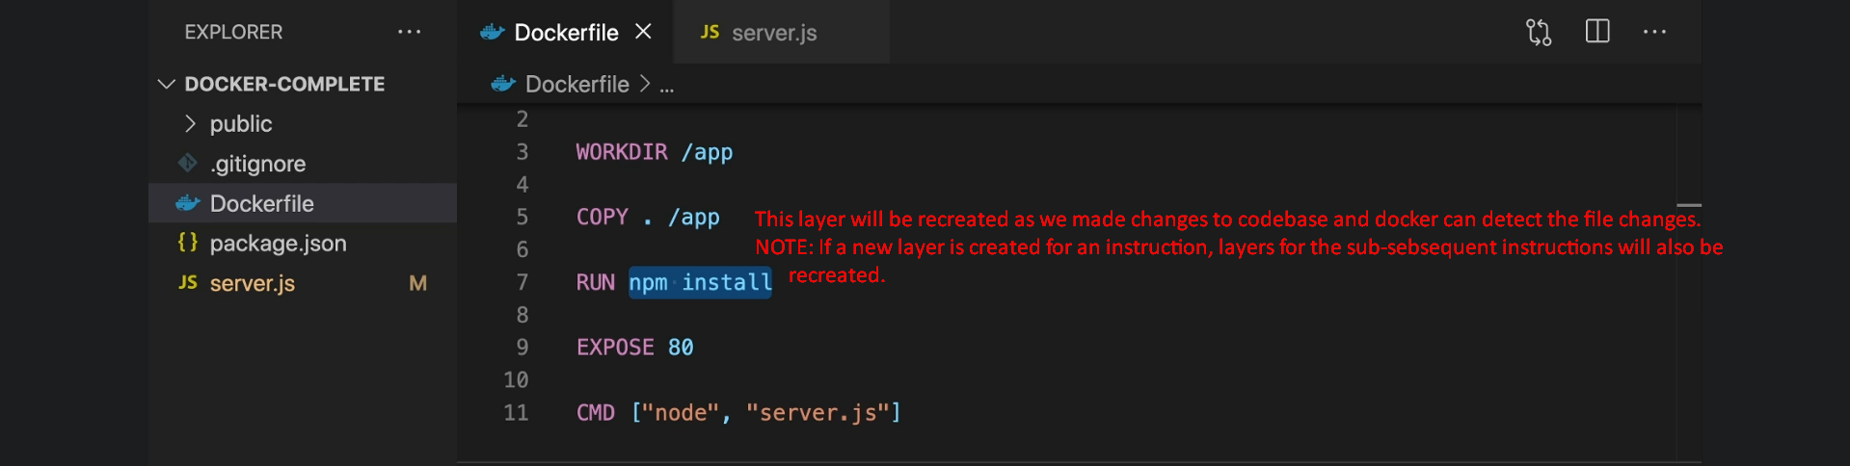
8. 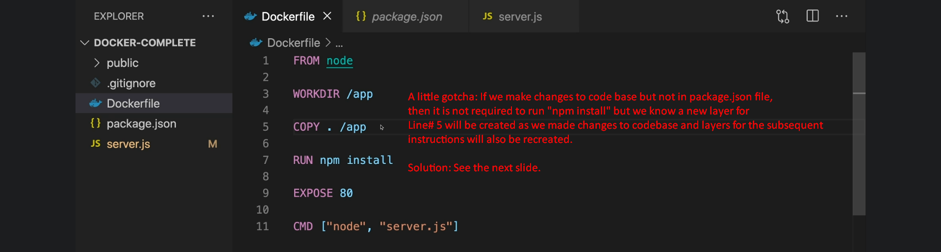
9. 